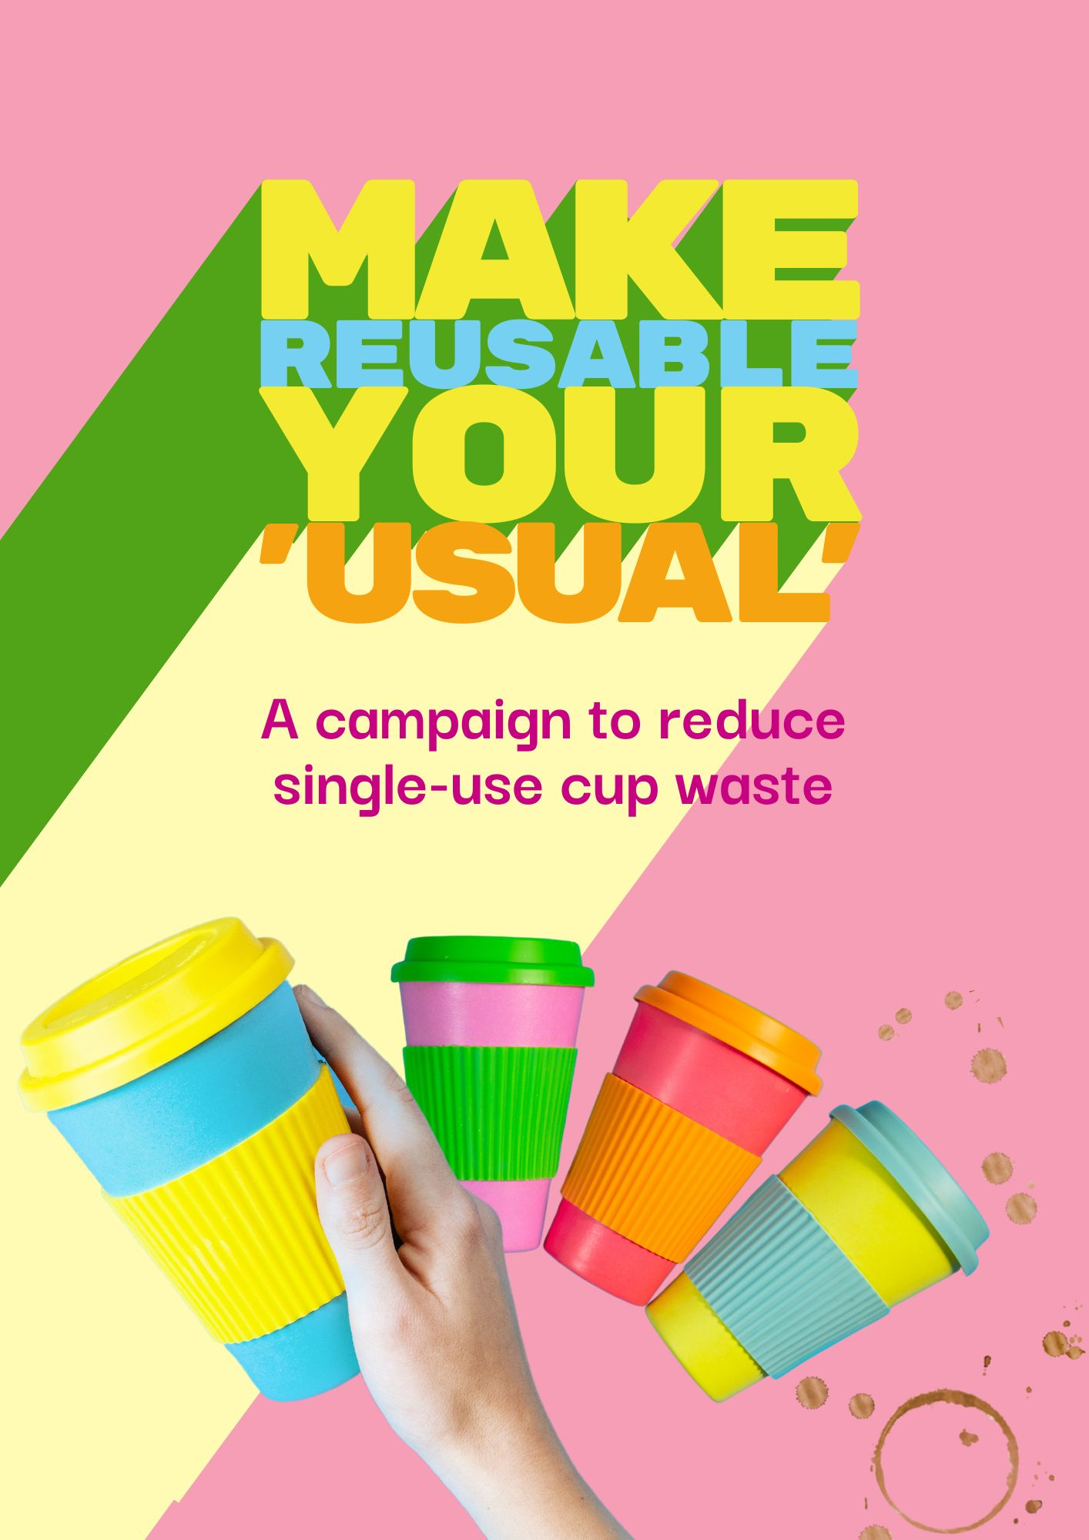

Campaign toolkit
The Make Reusable Your ‘Usual’ campaign is an initiative of the North East Waste Education Network, which comprises the seven councils of Alpine, Benalla, Indigo, Mansfield, Towong, Wangaratta and Wodonga, along with the alpine resorts of Mt Hotham, Falls Creek and Mt Buller/Stirling.
It aims to reduce single-use cup waste in the region by promoting the use of reusable coffee cups.
Designed to be playful, bright and filled with positivity, the campaign consists of printable collateral for use in key high-traffic spaces within workplaces, businesses and community facilities, and is supported by a range of digital resources for use across internal communication platforms, social media and email.
Workplaces are encouraged to consider supplying a ‘library’ of reusable coffee cups for staff to borrow and bring back, and to champion their use via the sharing of photographs and ‘stories’ on internal communication platforms, thus bringing the campaign to life.
The campaign has been developed in such a way that it can be shared with other businesses, workplaces and the broader community.

Printable collateral

The campaign includes the following printable resources:
- large, printable poster (PDF) for display at building exits, to remind staff leaving the building to take their reusable cups [poster 1];
- smaller, printable poster (PDF) for display with the ‘library’ of reusable coffee cups, encouraging staff to borrow a cup and wash it upon return [poster 2];
- A4-sized ‘pledge poster’ (PDF) for staff to circulate and sign as a commitment to ‘making reusable their usual’ [poster 3].

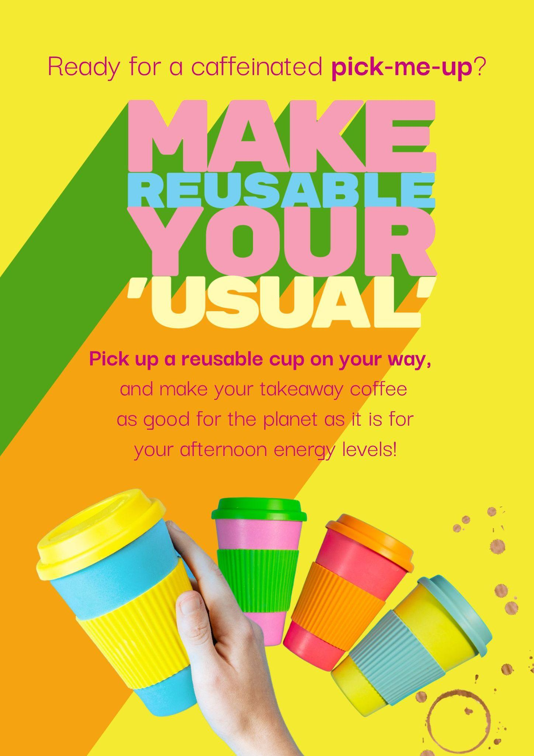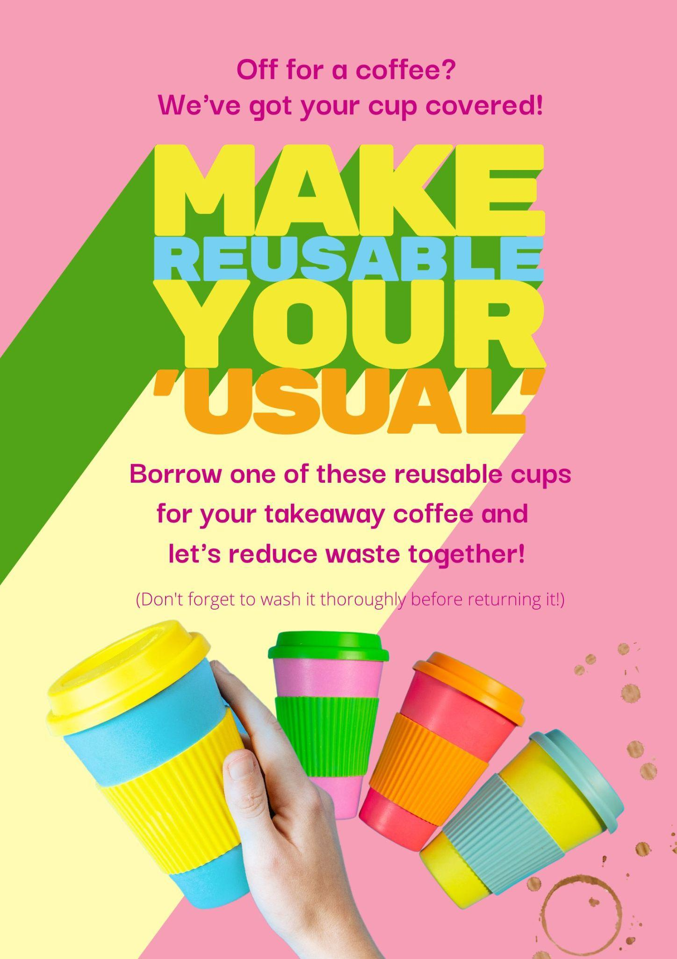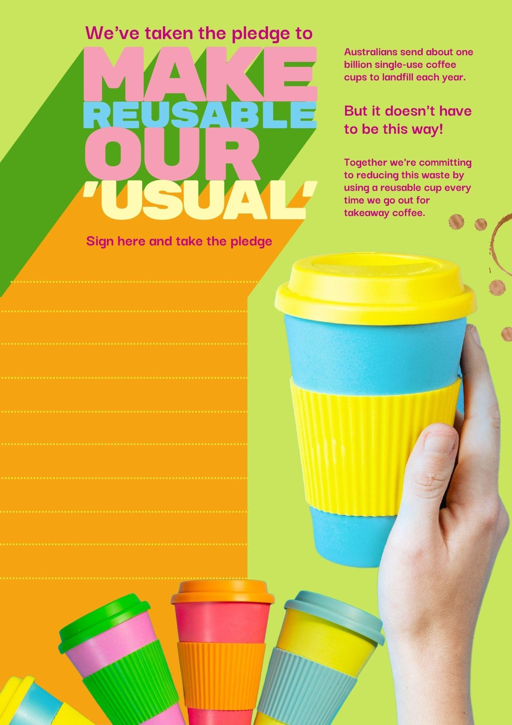

Poster 1 Poster 2 Poster 3

Social media toolkit

Tile 1
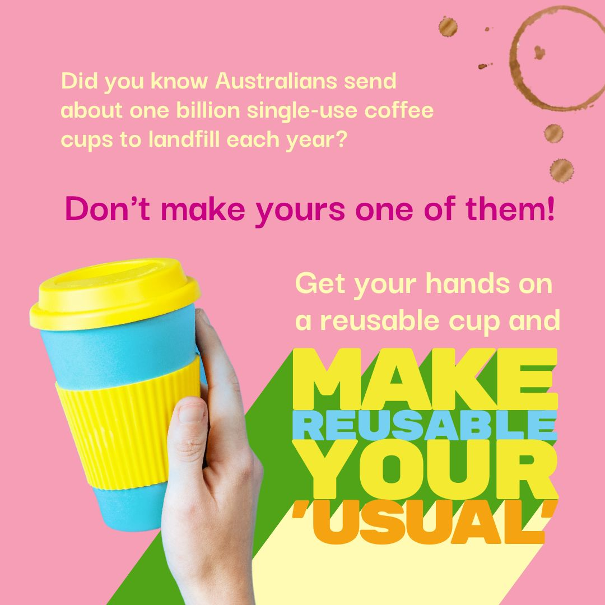 | Alternative text  A pink tile with an image of a person's hand holding a yellow and teal reusable coffee cup. There's a coffee stain in the corner of the tile. Multicoloured text reads: "Did you know Australians throw about one billion single-use coffee cups in landfill each year?* Don't make yours one of them! Get your hands on a reusable cup and MAKE REUSABLE YOUR 'USUAL'."  *Source: https://www.sustainability.vic.gov.au/recycling-and-reducing-waste/at-home/avoid-waste/minimise-single-use-items/disposable-coffee-cups | Caption  Even though single-use coffee cups look like they might be recyclable, the thin layer of plastic within each paper cup is incompatible with most local recycling processes. Which means that single-use coffee cups end up in landfill, or worse, rolling around as litter in our streets and waterways.  Your morning coffee can be as good for the environment as it is your energy levels, though - ditch the disposable cup for good and make reusable your 'usual.'  Going reusable doesn't require an investment in new gear (unless you really want to buy a snazzy reusable cup with a lid!) - it's as easy as going through your kitchen cupboard to find a mug that you can take with you for your takeaway coffee. Or DIY it, and find a jar with a lid for your takeaway drink - just wrap it in a few rubber bands to provide a bit of insulation!  The most important things to remember are to give your cup a good wash in hot soapy water between uses, and to take it with you each and every time you go out - chuck one in your bag or car so that you're never caught out!  Now, who wants a coffee?  #MakeReusableYourUsual #ReusableCup #Reusable #ReduceReuseRecycle #CoffeeCup #KeepCup #GoGreen #LowWaste #ZeroWaste

Tile 2
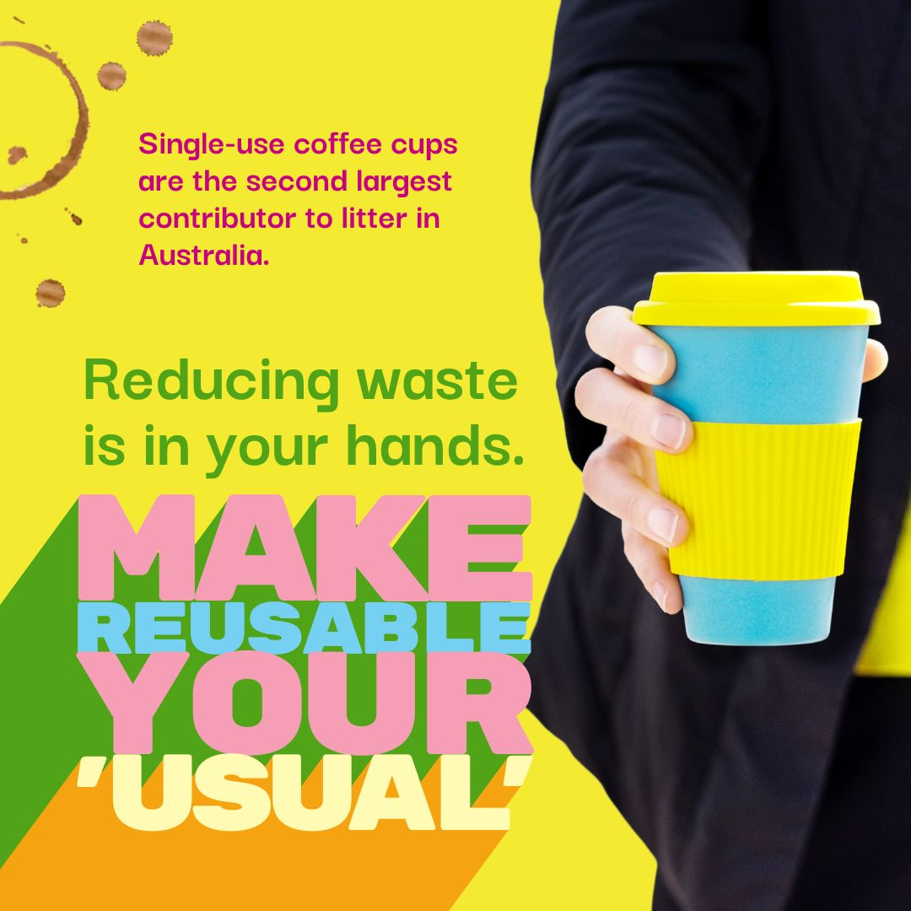 | Alternative text  A yellow tile with an image of a person's hand holding a yellow and teal reusable coffee cup. There's a coffee stain in the corner of the tile. Multi-coloured text reads: "Single-use coffee cups are the second largest contributor to litter in Australia.# Reducing waste is in your hands. MAKE REUSABLE YOUR 'USUAL'."  #Source: https://www.cleanup.org.au/single-use-coffee-cups | Caption  Australians send about one billion single-use coffee cups to landfill each year - a staggering 2,700,000 single-use cups every single day!*  Yours doesn't have to be one of them, though.  Commit to making reusable your ‘usual,’ and take a reusable coffee cup with you when you go for takeaway coffee. Whether it’s a reusable cup with a lid, your favourite china mug, or a jar with a few rubber bands around it for insulation, the most important thing is that you remember to take it with you in the first place.  Stash one in your bag, car or bike basket, keep one on your desk at work and get into the habit of never leaving the office without it! And don't forget to pack it when you go on holidays - you never know when you'll need to stop for a coffee break on the road!  Not only will your caffeine hit come with bonus warm and fuzzy feelings for doing something great for the planet, but your cafe might even give you a discount for bringing your own cup!  #MakeReusableYourUsual #ReusableCup #Reusable #ReduceReuseRecycle #CoffeeCup #KeepCup #GoGreen #LowWaste #ZeroWaste  *Source: https://www.sustainability.vic.gov.au/recycling-and-reducing-waste/at-home/avoid-waste/minimise-single-use-items/disposable-coffee-cups

Tile 3
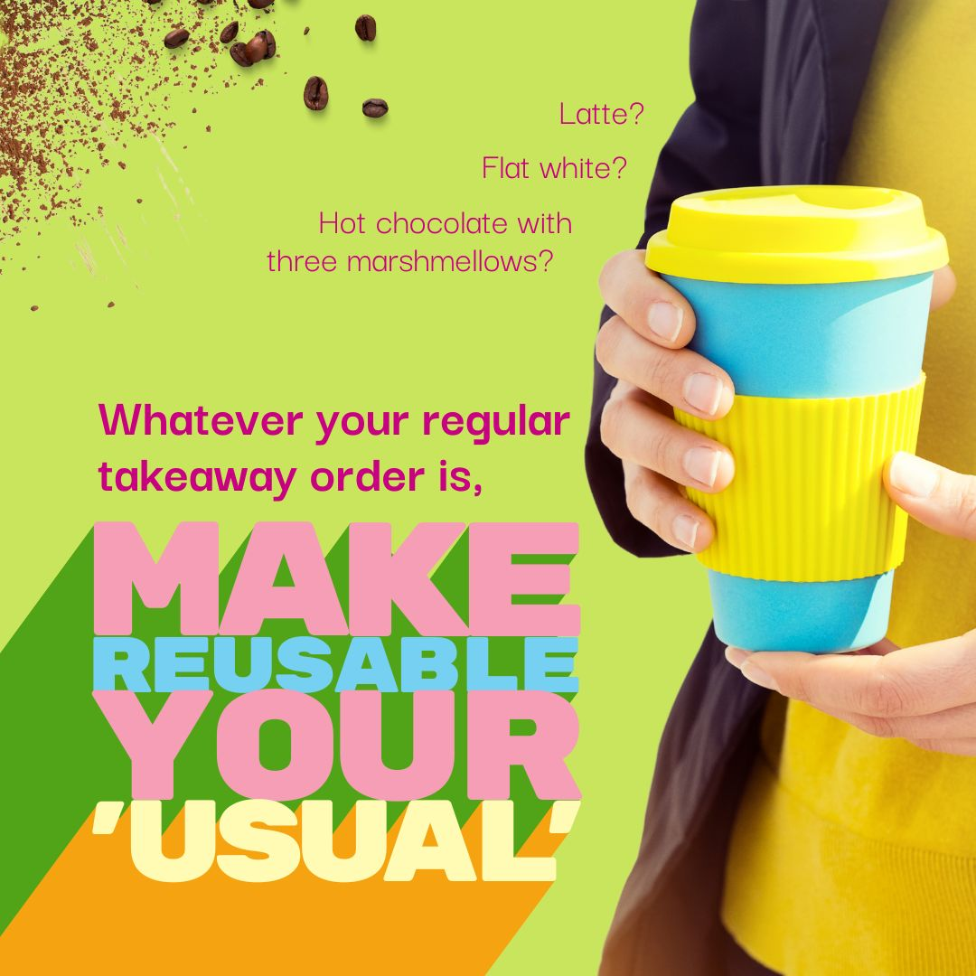 | Alternative text  A lime green tile with an image of a person's hands holding a yellow and teal reusable coffee cup. Chocolate powder and coffee beans are scattered in the corner of the tile. Multicoloured text reads: "Latte? Flat white? Hot chocolate with three marshmellows? Whatever your regular takeaway order is, MAKE REUSABLE YOUR 'USUAL'." | Caption  Are you on first-name terms with your barista? Do they know your order off by heart?  Whether you're a latte sipper or a cappuccino guzzler, if you're using a disposable cup to take your morning coffee away from the cafe, it's high time you made reusable your ‘usual’ and ditched single-use cups for good!  Single-use cups are the second largest contributor to litter on Aussie streets, after bottles.# And even though they might look like they're made from paper, they're lined with a thin layer of plastic which is incompatible with most local recycling processes. Which means as a nation, we send about a billion single-use cups to landfill each year.*  Fortunately, reducing this waste is easily within your grasp! Get yourself a snazzy reusable cup with lid - like a KeepCup - for your morning bevvy, or take your favourite china mug along and ask your barista to fill 'er up for you! And if you need a lid on your cup, reuse a jar with lid for your coffee - just wrap the jar in a few rubber bands as an insulative layer so your hands don't get too hot when the jar is full!  Whatever you choose to use, remember the golden rule - wash your reusable cup well with hot soapy water after each use, to keep things nice!  #MakeReusableYourUsual #ReusableCup #Reusable #ReduceReuseRecycle #CoffeeCup #KeepCup #GoGreen #LowWaste #ZeroWaste  #Source: https://www.cleanup.org.au/single-use-coffee-cups  *Source: https://www.sustainability.vic.gov.au/recycling-and-reducing-waste/at-home/avoid-waste/minimise-single-use-items/disposable-coffee-cups

Tile 4

The following tile has been designed to enable you to insert a photograph of a ‘reusable cup hero’ in the centre. You might like to use this in your internal communications, to highlight a team member who has taken the Make Reusable Your 'Usual' pledge, or on your social media platforms, to encourage community members to submit photographs of themselves with their reusable cups. Tweak and/or rewrite the text to make it suit your needs, campaign and community. This tile can be adjusted and a photo added to the transparent centre piece through Canva (if you’re not familiar with Canva check out the video tutorials which are easy to find online.) Canva is a free online design tool that is user friendly and easy to work in.

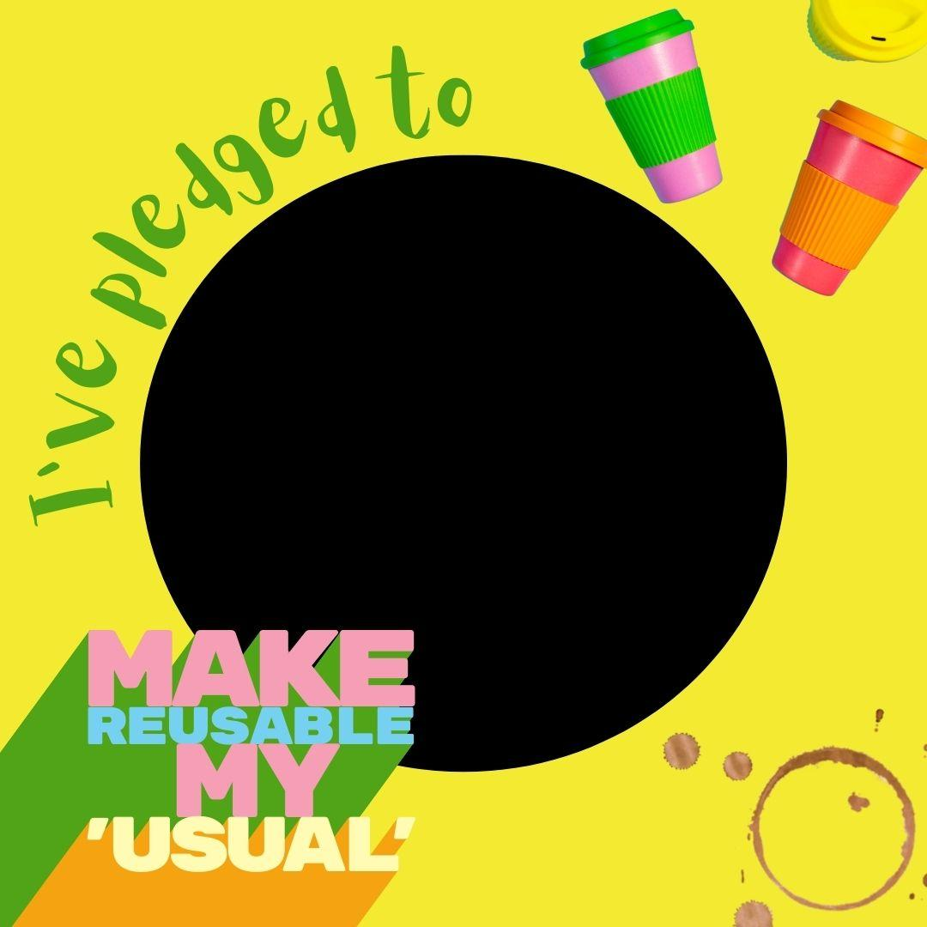 | Alternative text  A yellow tile with an image of brightly coloured reusable coffee cups scattered across one corner and coffee stain on another corner. There's a photograph [insert photo description here.] Multi-coloured text reads, "I've pledged to MAKE REUSABLE MY 'USUAL'." | Caption  With single-use coffee cups the second largest contributor to litter in Australia (after bottles#), we reckon each and every person who commits to using a reusable cup instead of a single-use one deserves a shout-out!  And so we'd like you to meet [INSERT PERSON'S NAME HERE]! They've pledged to make reusable their 'usual' by [using a reusable cup from council's reusable cup library/bringing their own reusable cup with lid/using a mug from home for their daily coffee/insert other option here.]  Next time you see [INSERT NAME HERE] around the office, make sure you give them a high five! And then go and pledge to make reusable YOUR usual too! It's easy! Just ask [INSERT NAME HERE]!  #MakeReusableYourUsual #ReusableCup #Reusable #ReduceReuseRecycle #CoffeeCup #KeepCup #GoGreen #LowWaste #ZeroWaste  #Source: https://www.cleanup.org.au/single-use-coffee-cups

Email graphics

The Make Reusable Your ‘Usual’ campaign includes two email graphics, designed to be inserted into the body of whole-of-team emails and sent as a fun and time-specific reminder for team members to take a reusable cup if they go out for a morning/afternoon coffee. Send one around at 10am and 2pm and get some conversation - and waste-reducing and cup-reusing - happening in your office!
Don't forget to include a fun and engaging subject line in your email - "Ready for a caffeine hit? Don't forget your cup!"; "Coffee time! Reusable cup time too!" Be creative and playful!

